**Edge Computing Laboratory**

**Lab Assignment 5**

**Name:** Yash Kulkarni

**Class:** TY AIEC Batch C

**Enrollment No:** MITU23BTCSD083

**Roll No:** D2233083

### **Title**

The “Hello World” of Edge Impulse Platform

**Introduction**

Edge Impulse is a development platform for machine learning on edge devices, targeted at developers who want to create intelligent device solutions. The "Hello World" equivalent in Edge Impulse would typically involve creating a simple machine learning model that can run on an edge device, like classifying sensor data or recognizing a basic pattern.

**Objective**

TinyML: Building and Training a Model

**Materials Required**

Raspberry Pi 4 / Nano BLE Sense Board

**Theory**

GPIO (General Purpose Input/Output) pins on the Raspberry Pi are used for interfacing with other electronic components. BCM numbering refers to the pin numbers in the Broadcom SOC channel, which is a more consistent way to refer to the GPIO pins across different versions of the

Here’s a high-level overview of steps you'd follow to create a "Hello World" project on Edge Impulse:

**Steps to Configure the Edge Impulse:**

1. Create an Account and New Project:
   * Sign up for an Edge Impulse account.
   * Create a new project from the dashboard.
2. Connect a Device:
   * You can use a supported development board or your smartphone as a sensor device.
   * Follow the instructions to connect your device to your Edge Impulse project.
3. Collect Data:

* + Use the Edge Impulse mobile app or the Web interface to collect data from the onboard sensors.
  + For a "Hello World" project, you could collect accelerometer data, for instance.

1. Create an Impulse:
   * Go to the 'Create impulse' page.
   * Add a processing block (e.g., time-series data) and a learning block (e.g., classification).
   * Save the impulse, which defines the machine learning pipeline.
2. Design a Neural Network:
   * Navigate to the 'NN Classifier' under the 'Learning blocks'.
   * Design a simple neural network. Edge Impulse provides a default architecture that works well for most basic tasks.
3. Train the Model:
   * Click on the 'Start training' button to train your machine learning model with the collected data.
4. Test the Model:
   * Once the model is trained, you can test its performance with new data in the 'Model Testing' tab.
5. Deploy the Model:
   * Go to the 'Deployment' tab.
   * Select the deployment method that suits your edge device (e.g., Arduino library, WebAssembly, container, etc.).
   * Follow the instructions to deploy the model to your device.
6. Run Inference:
   * With the model deployed, run inference on the edge device to see it classifying data in real-time.
7. Monitor:
   * You can monitor the performance of your device through the Edge Impulse studio.

**Screenshots:**

1. Dataset Image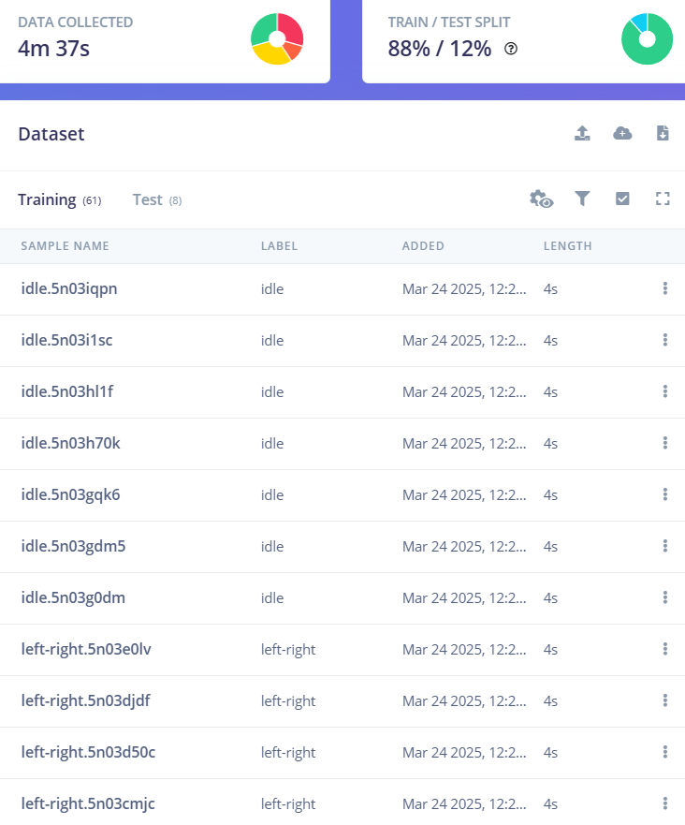

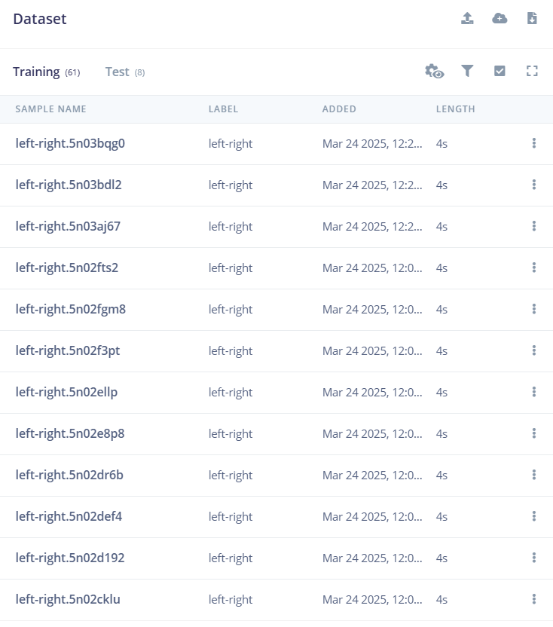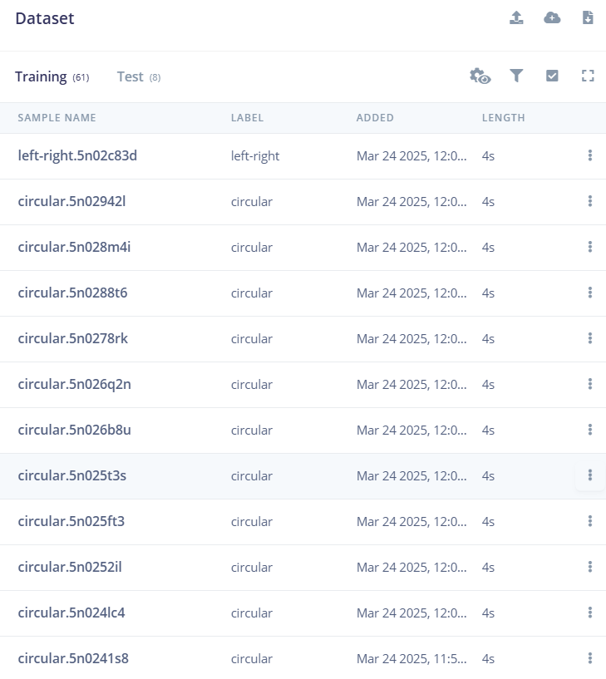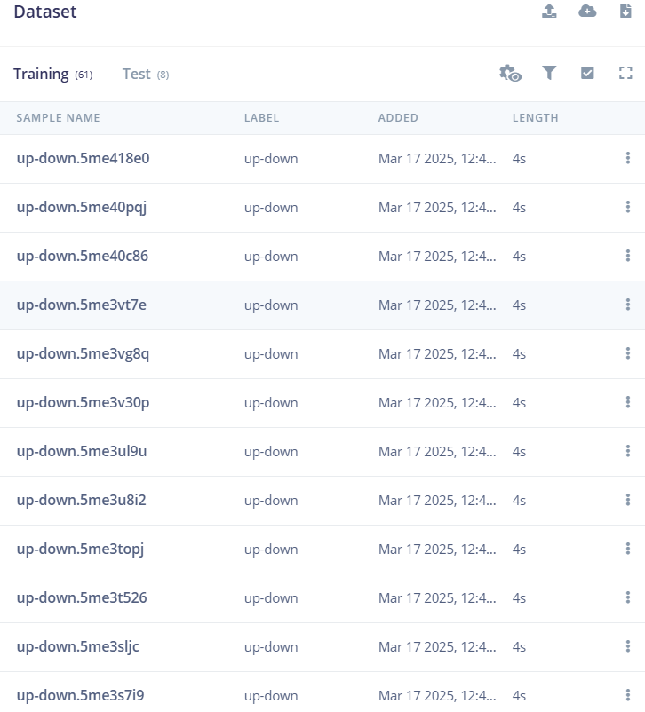

1. Feature extraction - Image

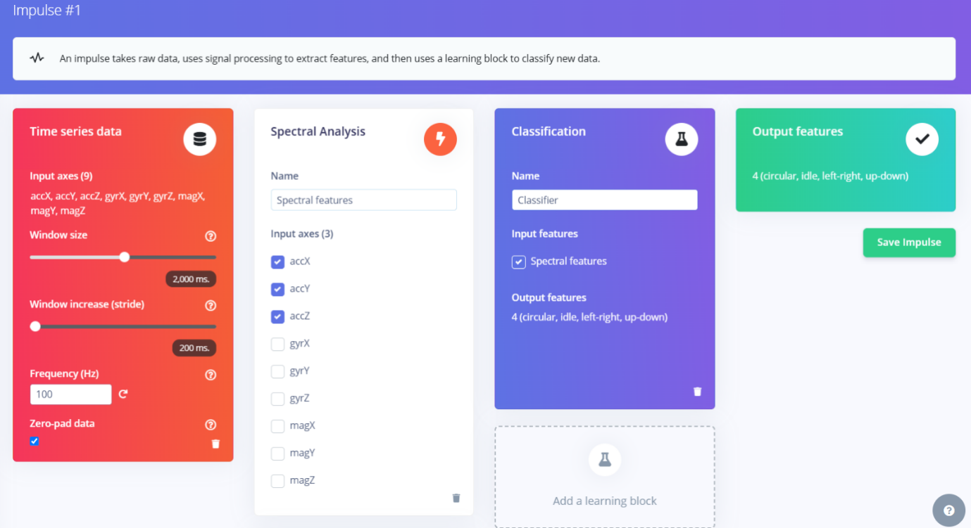

1. Accuracy / Loss - Confusion Matrix – image

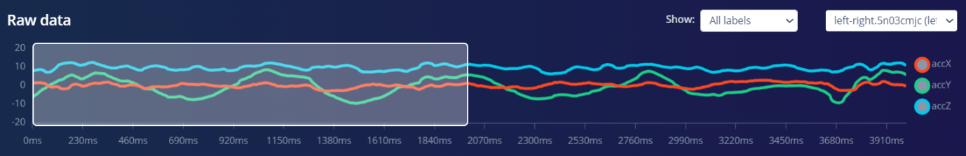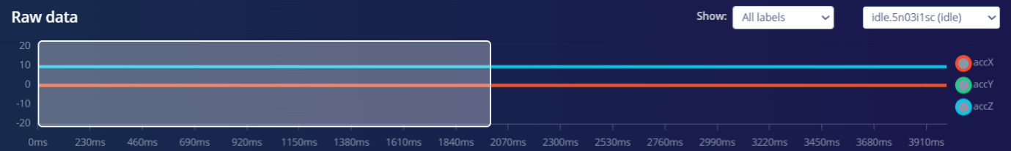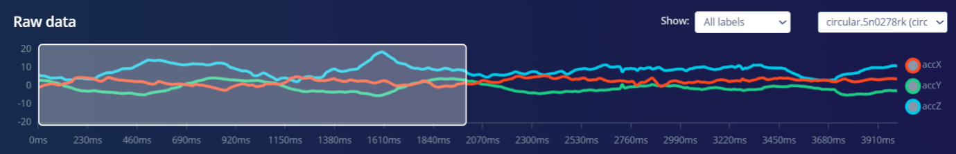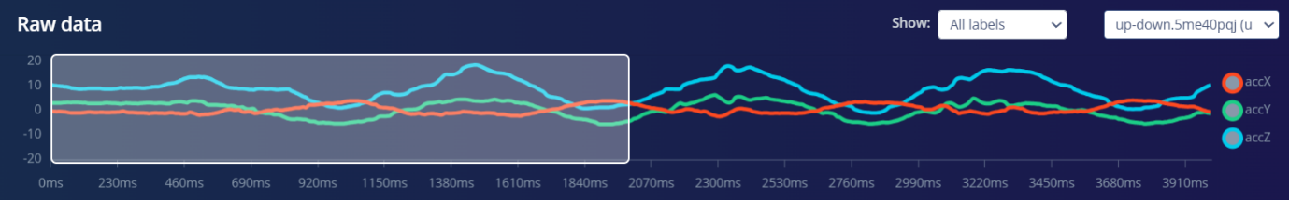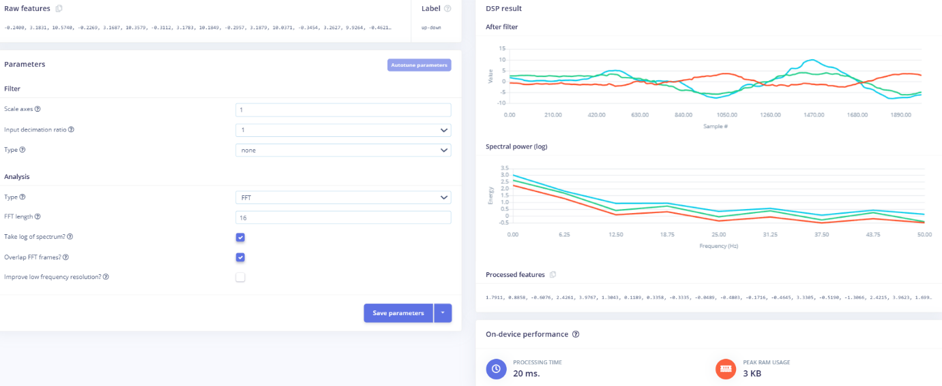

1. Validation Result – Image
2. Copy the code of Arduino Sketch
3. Screen shot of Arduino Terminal - Result

**Conclusion:-** Created and deployed ML model with sound based data on edge device